1.Describe how odometry errors on a moblle robot might occur and explain two methods

how they could be corrected.

里程计 – Odometry；误差类型 - Error types

Deterministic (e.g. drift)； - Non-deterministic (non - systematic, e.g. surface irregularities)

（例如表面不平整）； 校准 – Calibration；移动机器人 - Mobile robot

2. With respect to mobile robots:(G)

(a)Explain why IR sensors might be used in preference to sonar sensors.

1. **Precision and Resolution**:
   * IR sensors offer higher precision and resolution for short - range detection.
   * Useful for detecting small objects or details.
2. **Response Time**:
   * Faster response time compared to sonar sensors.
   * Ideal for high - speed or rapid - response systems.
3. **Size and Cost**:
   * Smaller and less expensive.
   * Suitable for space - and budget - constrained applications.
4. **Immunity to Acoustic Noise**:
   * Not affected by noise as they operate on light.
   * Reliable in noisy environments.

(b)Explain why sonar sensor might be used in preference to IR sensors.

1. **Long - Range Detection**:
   * Better for long - range sensing.
   * Used in applications like AUVs for far - off object detection.
2. **Penetration Ability**:
   * Can penetrate water, fog, and some solids.
   * Useful in adverse environmental conditions.
3. **Wide - Angle Coverage**:
   * Provides a wider detection angle.
   * Helps in covering larger areas for object detection.
4. **Less Affected by Surface Properties**:
   * Detection is not influenced by surface color or reflectivity.
   * Consistent performance in various surface environments.

3. Name 4 sensors discussed in this course that can resolve the range of objects. For each

sensor named briefly explain how it work.

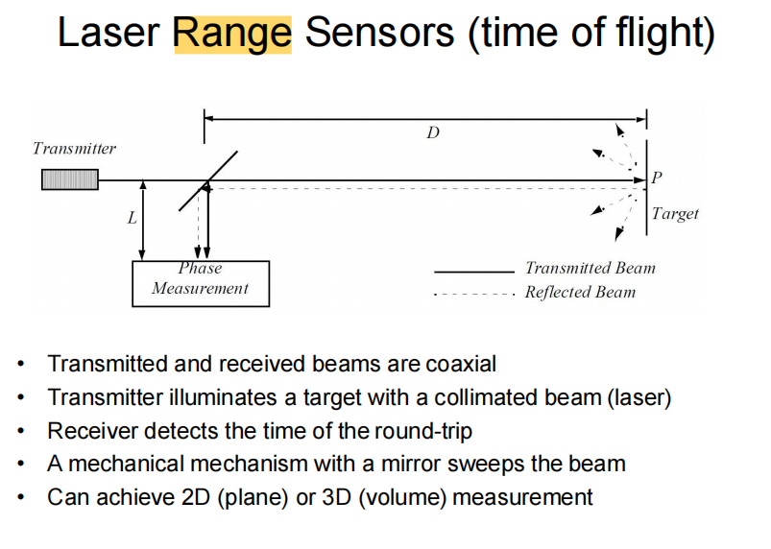

4. Briefly explain the levels 1 to 4 of automation attributed to autonomous vehicles.

6. Two methods for acquiring a map of the environment using odometry are outline

segments and an occupancy grid. Explain these mapping methods.

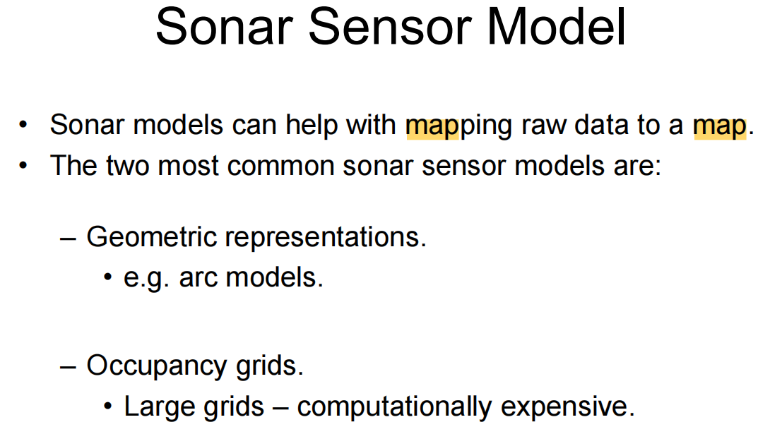

7. State one advantage an outdoor mobile robot has over an indoor mobile robot when

navigating the environment? State one disadvantage an outdoor mobile robot has over

an indoor mobile robot when navigating the environment?

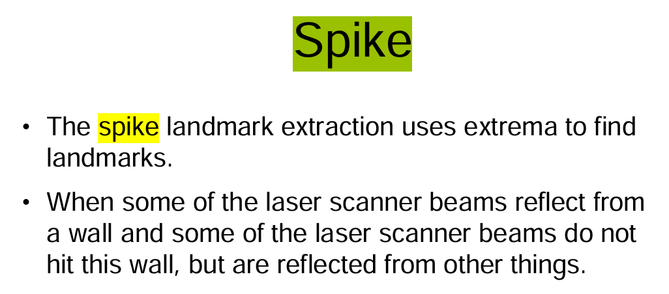

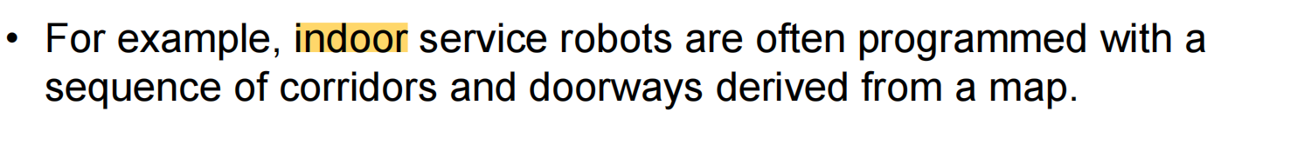

8．Briefly explain how a robot pool cleaner might go about navigating its environment.

同上

9. Explain the difference between a mobile robot control systems that reacts to the environment and one that works by planning a path through the environment. List one advantage and one disadvantage of each of these controllers.

**Deliberative**

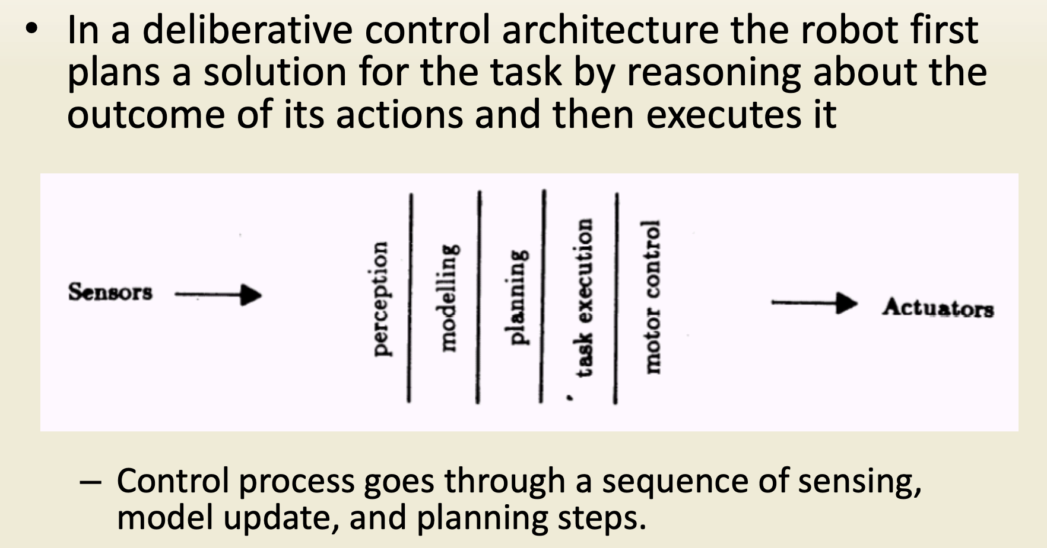

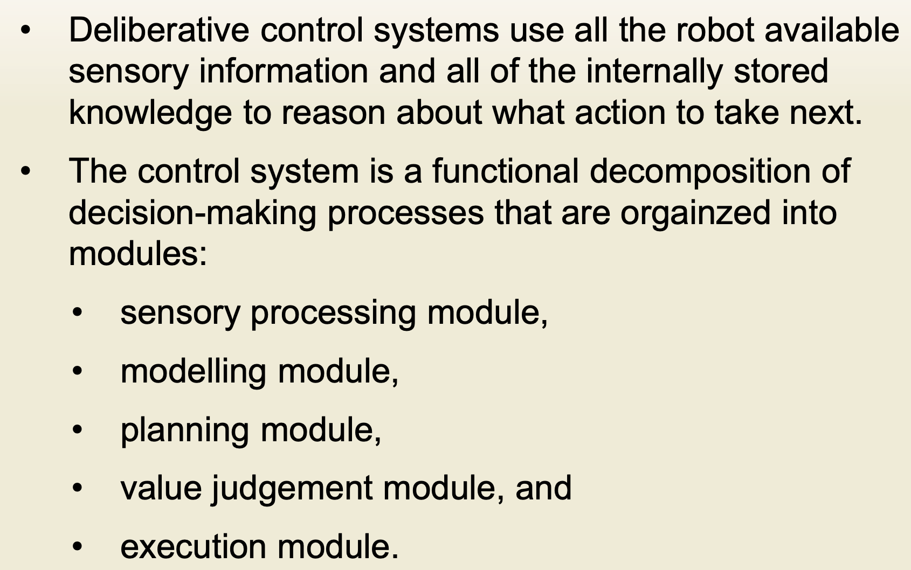

功能分解，不同模块联合完成整个决策制定过程

**Reactive**

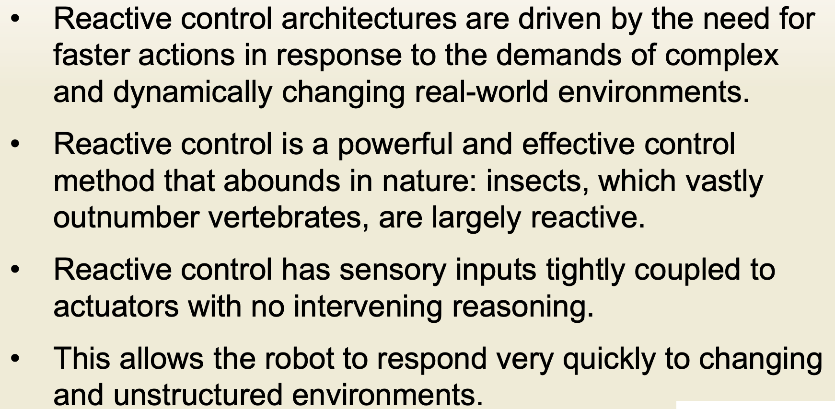

第三点翻译：反应性控制的感官输入与执行器紧密耦合，没有介入推理。（个人理解传感直通行为，中间没有planning 环节）

10. In terms of sensing and control, explain how a bookmobile robot could navigate the inside of a library building.

传感：visual、IR、sonic都行，Spike提取landmark、用deliberative control，预先保存图书馆地理信息

11. What is meant by the piano mover problem? What type of robots does this apply to? Describe two ways how this problem can be overcome.

Motion planning. Bug1, bug2 algorithm

12. What is meant by supervised learning, unsupervised learning and learning by demonstration? Give an example for each learning paradigm.

监督学习是利用数据的特征和标签来训练一个模型，使模型能够对任意给定的输入，对其相应的输出做出一个好的预测，即得出一个所谓的正确答案。监督学习可以分为两大类：回归分析和分类，二者之间的区别在于回归分析针对的是连续数据，而分类针对的是离散数据。

非监督学习为直接对数据进行建模，训练数据中只有特征没有标签，而且事先并不知道输入数据对应的输出结果是什么，最终结果为多个结构。。其中包含聚类分析与特征变量关联等算法。即类似于将一个数据集分为多个集合，而事先并不知道集合的种类与个数，如将新闻按照相同的事件分组。

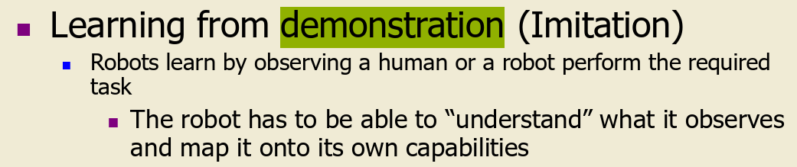

13. 同9

14. In terms of localisation and mapping explain how a mobile robot could navigation the environment with the use of: (a) continuous landmarks (b) non continuous landmarks

连续的RANSAC，This method can be used to extract lines from a laser scan that can in turn be used as landmarks. 非连续的Spike，因为Spike landmarks rely on the landscape changing a lot between two laser beams. This means that the algorithm will fail in smooth environments.

15. What is the credit assignment problem with respect to mobile robots?

加强学习中，奖励或惩罚如何界定，奖励和惩罚的幅度如何确定（In reinforcement learning, how to define reward or punishment, and how to determine the extent of reward and punishment）

16. Name 4 sensors discussed in this course and discuss their function and limitations?

Visual、tactile、IR（temperature限制）、sonic、color。。。想不出就说distortion（干扰）

17. What is an occupancy grid? How might you devise an occupancy grid that can cope with odometry errors?

An occupancy grid is a common representation used in robotics and autonomous systems to model and perceive the environment. It divides the environment into a grid of cells and assigns a probability or binary value to each cell indicating the likelihood of occupancy by an object or obstacle.

18. In terms of sensing and control briefly explain how an indoor mobile could be devised to find its charging bay.

Spike、和充电槽交流用radar、wifi等，control还是deliberative

19. What is sensor fusion? Give an example of sensor fusion and explain how the example given works.

Use • Over multiple sensors • Over multiple time steps • Incorporate sensor model to lower sensor noise

20. Why might a simulator be used to assist with the development of a mobile robot control system? What special considerations need to be taken into account when devising a mobile robot simulator.

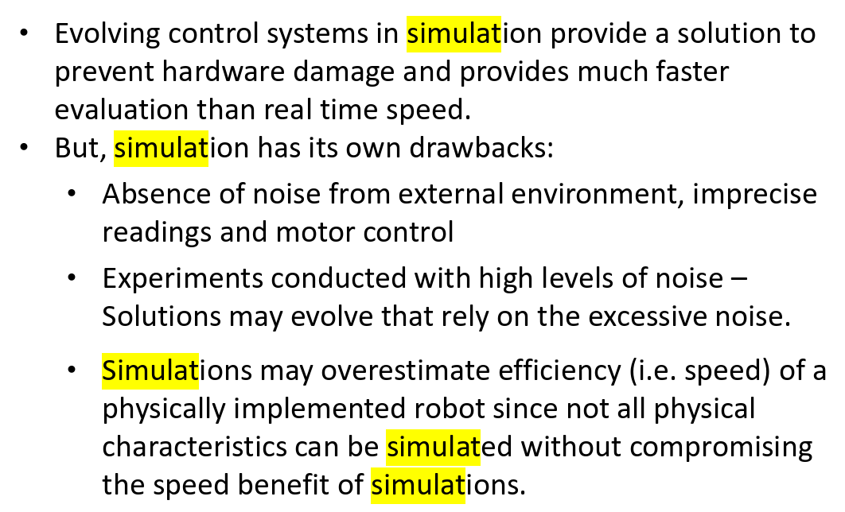

21. In Labview what is a cluster? How would you access the data in a cluster?

簇（Cluster）是一种数据类型，它的元素可以是不同类型的数据。它类似于C语言中的struct。使用簇可以把分布在流程图中各个位置的数据元素组合起来，这样可以减少连线的拥挤程度。减少子VI的连接端子的数量。Reduce connection

Use Bundle By Name to access data

22. What is a feedback node used for in Labview? How does this differ to a shift register?

反馈节点保存上一次执行更新的数据，可以用于循环结构，也可以用于其它代码。

1、反馈节点有启用输入端，可以设置启用条件。 2、反馈节点可以设置延时次数，规定每多少次迭代反馈一次数据。 3、反馈节点相当于为所在VI创建了移位寄存器；而移位寄存器只是为所在循环结构创建

（1, the feedback node has enabled the input terminal, you can set the enabling conditions. 2. The feedback node can set the number of delays to specify how many iterations to feed back the data. 3. The feedback node is equivalent to creating a shift register for the VI where it resides; The shift register is created only for the loop structure in which it resides）